**Chapter 4 Mail**

Mail is a E-mail function allow you to communicate and sent and receive mail from others more easily as in the SmartLeg@l.

* To open Mail, on the **SmartLeg@l** navigation, click **Mail**.

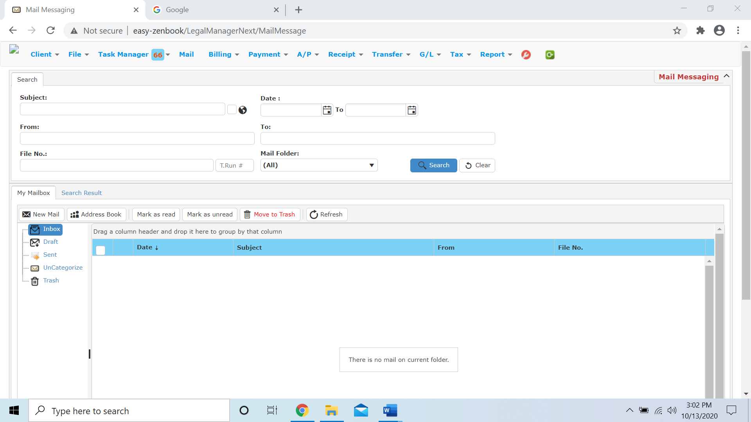

Figure: Mail

Mail Module to provide search function as other module enable to find e-mail that you wish to view more easily.

* Search the mail you wish to view through type the search criteria.
* To start a new search or to clear the search results, click ‘**Clear**’.

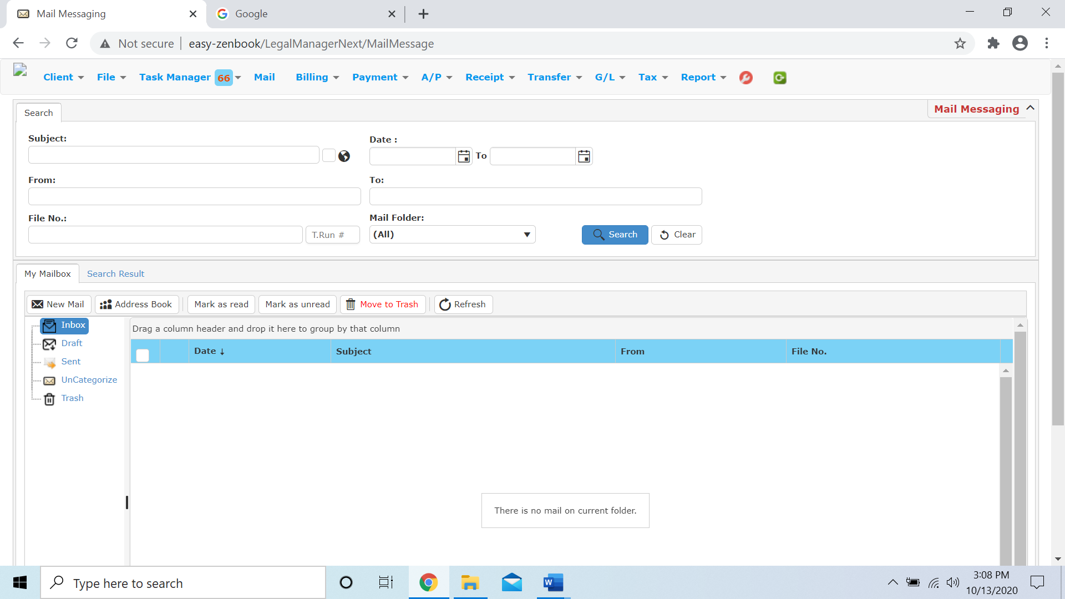

Figure: Mail – Search Mail

**Searched Result**

* Click ‘**Search**’ once, to show all mails.
* The Searched result will appeal at below, otherwise it will shown no record availble if the client you searched do not exist.

Figure: Mail – Search All Mails

To sent a new mail, click ‘**New Mail**’ in My Mail as ‘Figure: New Mail’ shown

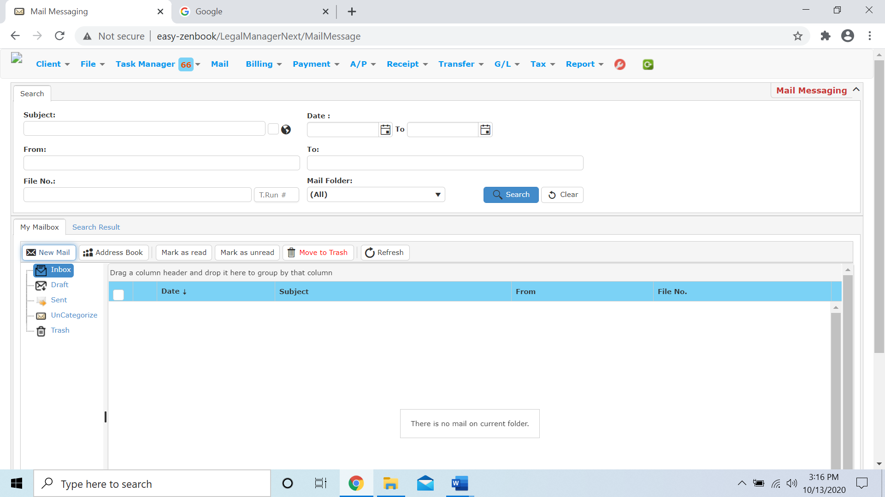

Figure: New Mail

* Type E-mail of the person you wish to sent in ‘**To:**’
* Type Subject or Title of the E-mail in ‘**Subject:**’
* You may attach some files you want to send with the mail with click ‘**Select Files**’in the **Attachments**.
* Fill your message at below and you may change you text font and style at the navigation inside the new mail function
* After you finish to fill the E-mail click ‘**Send**’to send the mail
* You can click ‘**Save**’ then your mail with save to **Draft**

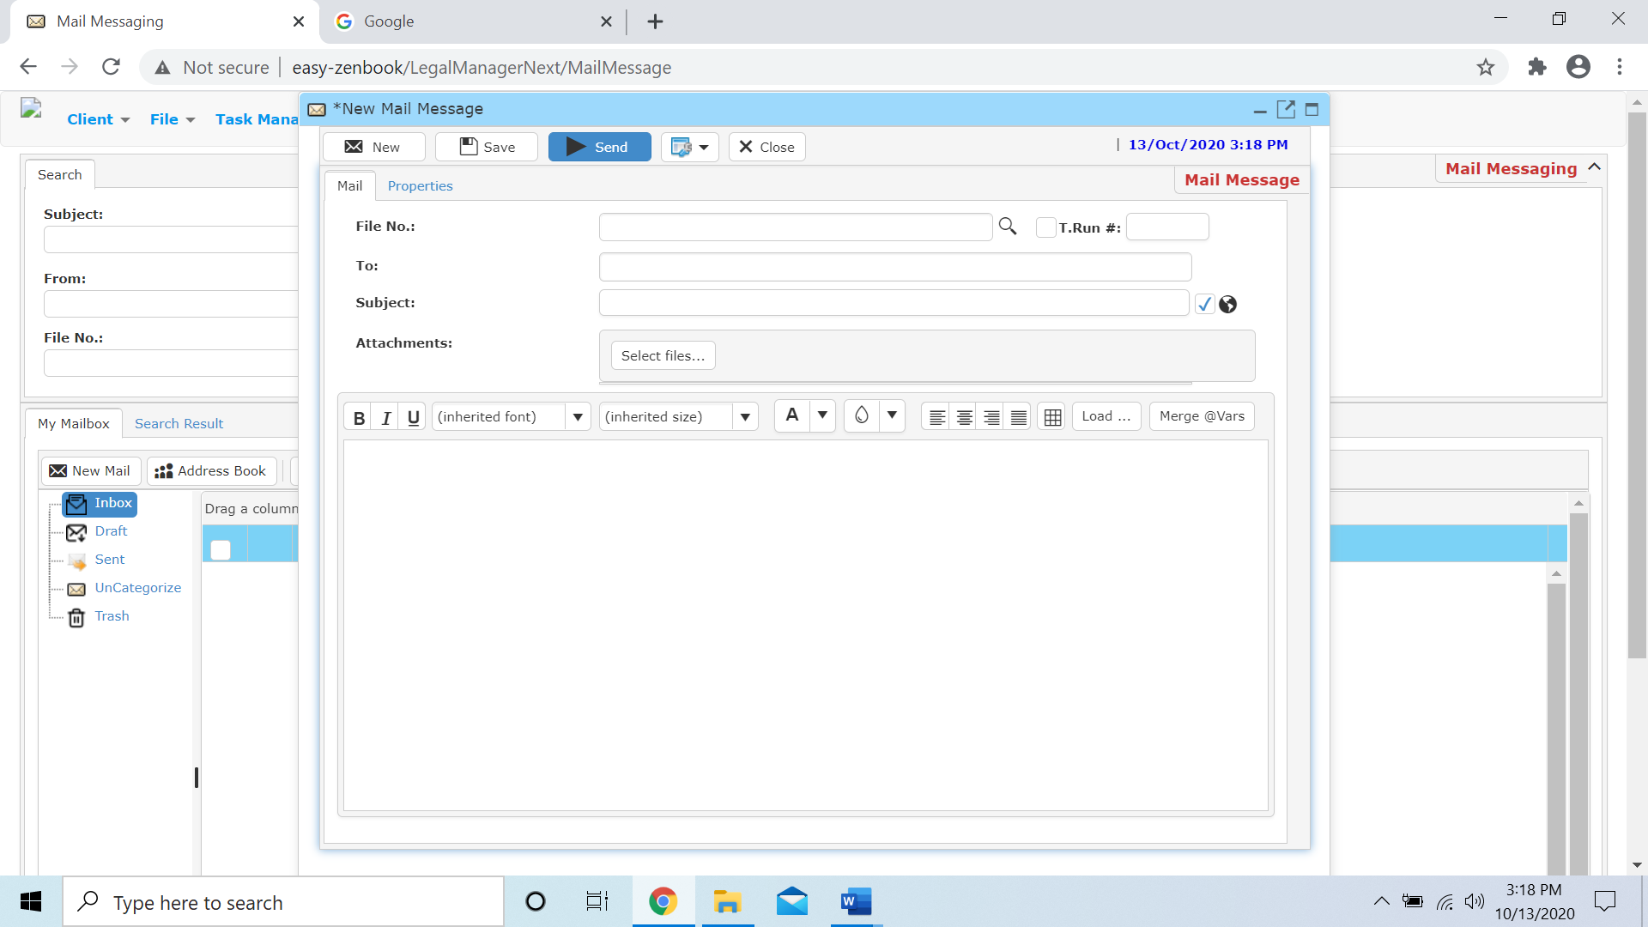

Figure: New Mail – Input Form